|  |
| --- |
| **Australian Curriculum- Mathematics**  Planning and Programming for Quality Teaching & Learning  Consistency of Teacher Judgement – *Western Adelaide Regional Project* |

**Summative Assessment Tasks Exemplars**

Task design needs to allow students to demonstrate achievement across the full range of standards (A-E). The Western Adelaide Region Summative Assessment Tasks aim to provide:

* *Quality assessment tasks which allow entry level for all students*
* *An opportunity for students to demonstrate achievement, understanding and skill at a higher level*
* *Support for consistency of teacher judgement and student performance in line with AC standards*
* *Opportunities for learning teams to engage in professional discussions around moderation of student work samples and evidence of learning*
* *An assessment tasks overview page, highlighting the ‘big ideas’ and common student misconceptions that could be explored*
* *A model for teaching teams to further develop additional assessment tasks across all strands and sub-strands*

**Effective implementation of the Australian Curriculum**

This requires a whole site approach to ensure **Curriculum coherence and Quality teaching and learning** to enable the highest possible learner outcomes. This includes:

*-Agreed assessment approaches (clear learning intentions, success criteria and assessment criteria) and moderation processes for consistency of teacher judgement*

*-Common approaches to rigorous, evidence based reporting of student progress against clear achievement standards*

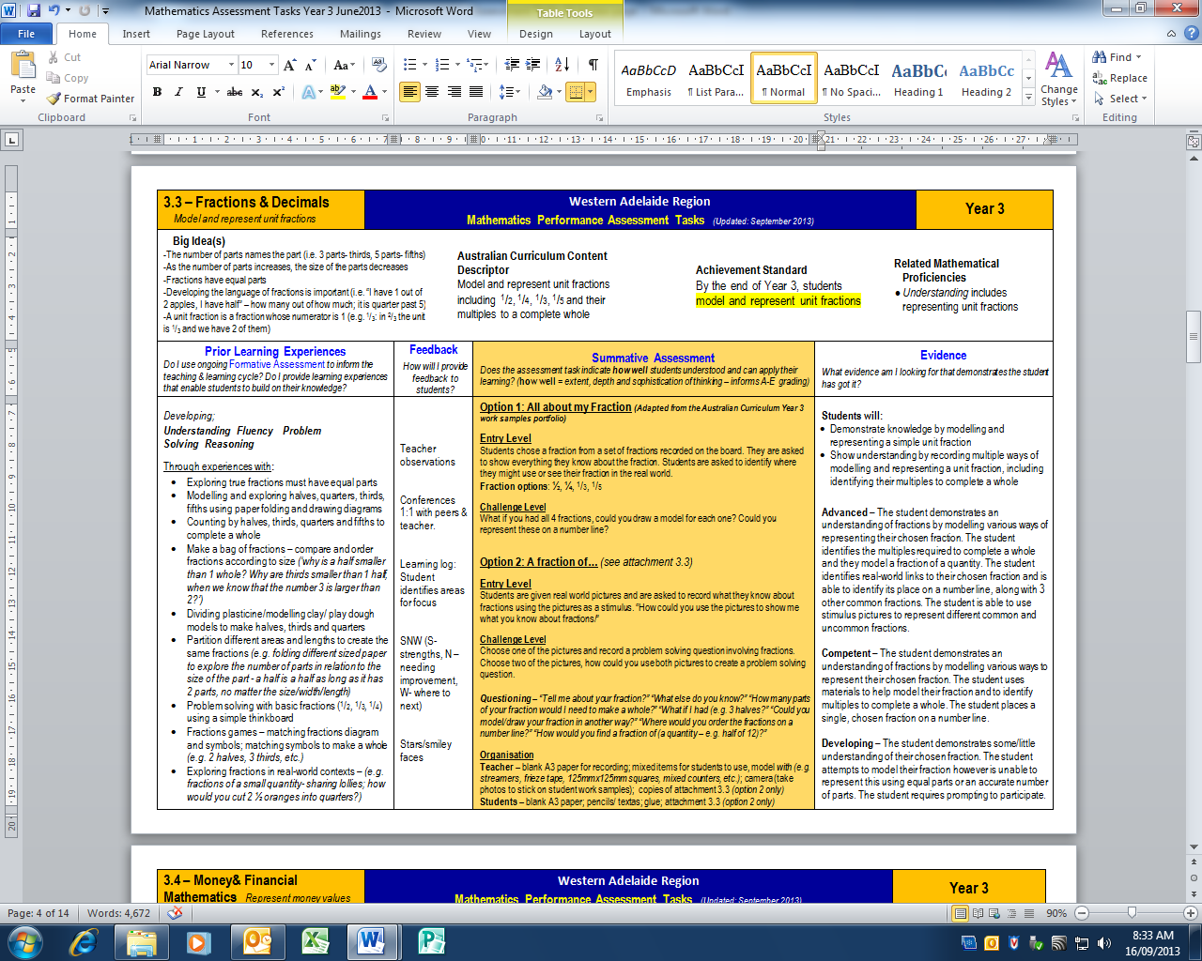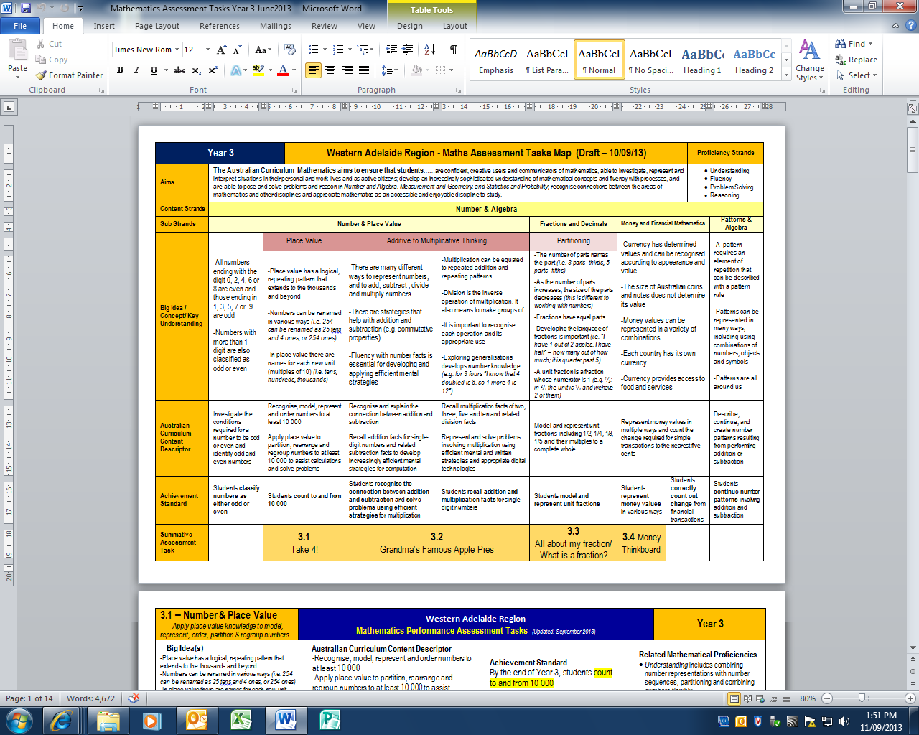

Provides direct links to the Australian Curriculum Content Descriptors and Achievement Standards

*For further information contact Karly Hefferan—Curriculum Consultant Western Adelaide Region*

Provides a common summative assessment task including; entry and challenge levels, possible questioning and organisation required. Suggested resource sheets are included as attachments. Some tasks may provide two options for assessment.

Identifies the related mathematical proficiencies

Evidence of student achievement is provided as indicators of advanced, competent and developing learners, which can be aligned to A-E grading

**Summative Assessment Task Exemplars**

Suggests possible feedback for students

Provides an indication of learning experiences required, **prior to implementing** the assessment task

Identifies the ‘big ideas’ and student misconceptions for the sub strand

**Summative Assessment Tasks Overview Page**

Identifies the ‘big ideas’ and student misconceptions for each sub strand and highlights where these fit in relation to ‘The Big Ideas in Number’ framework

Identifies Summative Assessment Tasks aligned to Achievement Standards