Geography Inquiry Planner: Incorporating Learning Design & the Australian Curriculum Year _____ Inquiry unit
What do we want them to learn? |  |  |  |  |  |  |  |  |  |  |  | How will we know if they’ve learnt it?
Big Idea: |  |  |  | AC Key Inquiry Questions: |  |  |  |  |  |  |  | Assessment for Learning  Learning Expectations  Clarifying and sharing learning intentions and criteria for success  Questioning  Engineering effective discussions, questions and learning tasks that develop deep understanding and elicit evidence of learning  Feedback  Providing feedback that moves learners forward. (Meaningful & timely)  Self-Assessment  Activating students as the owners of their own learning.  Peer Assessment  Actively engaging students as instructional resources for one another in learning and reflection.  TfEL Domains:  Intellectual Change  2.4- Challenge students to achieve high standards with appropriate support  4.4- Communicate learning in multiple modes  Formative Assessment  2.1- Develop democratic relationships  2.3- Negotiate learning  3.4- Promote dialogue as a means of learning  4.1- Build on learners’ understandings  4.3- Apply and assess learning in authentic contexts
Geographical Knowledge: |  |  |  |  |  |  | Geographical Understanding:
Geographical Concepts: What are the key concepts to be developed? What are the key inquiry questions?
Place | Space |  | Environment |  | Interconnection |  |  | Sustainability | Scale |  | Change
Content Descriptions- Geographical Inquiry and Skills
Observing, questioning and planning-
Collecting, recording, evaluating and concluding
Interpreting, analysing and concluding
Communicating
Reflecting and responding
General Capabilities:  Literacy Numeracy ICT capability  Critical and creative thinking Personal and social capability  Ethical behaviour Intercultural understanding |  |  |  |  |  | Cross Curriculum Priorities:  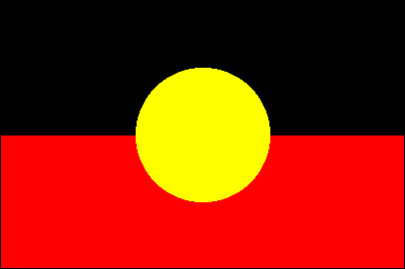  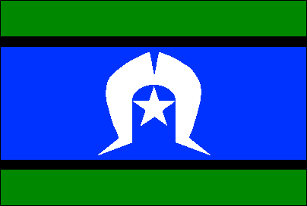  Aboriginal and Torres Strait Islander histories and cultures  Asia and Australia’s engagement with Asia  Sustainability
Correlations with History Content and Concepts: Which geographical concepts and knowledge will support student learning in History?

How will we get there?
What do the children bring? How will I know? How will I establish prior knowledge and understanding? |  |  |  |  |  |  | Engage: |  |  | Challenge: |  |  | Differentiate/Scaffold:

How will we get there using the inquiry stages of geography? |  | How will we know if they’ve learnt it?
Inquiry Stages | What will the students be doing? | Assessment Activity/Task | Timeframe | Teacher preparation & required resources
Observing, questioning and planning
Collecting, recording, evaluating and representing
Interpreting, analysing and concluding
Communicating
Reflecting and responding
Links to other learning areas: |  | Future Learning Considerations:  Karly Hefferan, 2014

