History Inquiry Planner: Incorporating Learning Design & the Australian Curriculum
What do we want them to learn? |  |  |  |  |  |  |  |  |  |  | How will we know if they’ve learnt it?
Big Idea: |  |  |  | AC Key Inquiry Questions: |  |  |  |  |  |  | Assessment for Learning  Learning Expectations  Clarifying and sharing learning intentions and criteria for success  Questioning  Engineering effective discussions, questions and learning tasks that develop deep understanding and elicit evidence of learning  Feedback  Providing feedback that moves learners forward. (Meaningful & timely)  Self-Assessment  Activating students as the owners of their own learning.  Peer Assessment  Actively engaging students as instructional resources for one another in learning and reflection.  TfEL Domains:  Intellectual Change  2.4- Challenge students to achieve high standards with appropriate support  4.4- Communicate learning in multiple modes  Formative Assessment  2.1- Develop democratic relationships  2.3- Negotiate learning  3.4- Promote dialogue as a means of learning  4.1- Build on learners’ understandings  4.3- Apply and assess learning in authentic contexts
Historical Knowledge: |  |  |  |  |  | Historical Understanding:
Historical Concepts: What are the key concepts to be developed? What are the key inquiry questions?
Sources | Continuity & Change | Cause & Effect |  | Perspectives |  |  | Empathy | Significance |  | Contestability (Year 7-10)
Content Descriptions- Historical Inquiry and Skills
Chronology, terms and concepts
Historical questions and research
Analysis and use of sources
Perspectives and interpretations
Explanation and communication
General Capabilities:  Literacy Numeracy ICT capability  Critical and creative thinking Personal and social capability  Ethical behaviour Intercultural understanding |  |  |  |  |  | Cross Curriculum Priorities:  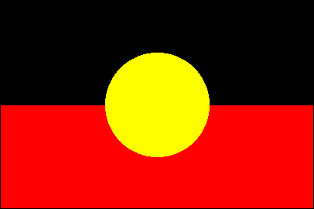  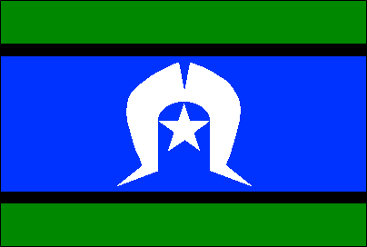  Aboriginal and Torres Strait Islander histories and cultures  Asia and Australia’s engagement with Asia  Sustainability
Connections with Geography Content and Concepts: Which historical concepts and knowledge will support student learning in Geography?

How will we get there using the inquiry stages of History? How will we know if they’ve learnt it?
What do the children bring? How will I know? How will I establish prior knowledge and understanding? |  |  |  |  | Engage: |  |  |  | Challenge: |  |  | Differentiate/Scaffold:

Big Idea/ Inquiry Question | Student Learning Task/Activity Description | Assessment Activity/Task | Inquiry Stages | Timeframe | Teacher preparation & required resources
- Chronology, terms and concepts
- Historical questions and research
- Analysis and use of sources
- Perspectives and interpretations
- Explanation and communication
- Chronology, terms and concepts
- Historical questions and research
- Analysis and use of sources
- Perspectives and interpretations
- Explanation and communication
- Chronology, terms and concepts
- Historical questions and research
- Analysis and use of sources
- Perspectives and interpretations
- Explanation and communication
- Chronology, terms and concepts
- Historical questions and research
- Analysis and use of sources
- Perspectives and interpretations
- Explanation and communication
- Chronology, terms and concepts
- Historical questions and research
- Analysis and use of sources
- Perspectives and interpretations
- Explanation and communication
Links to other learning areas: |  |  | Future Learning Considerations:  Karly Hefferan, 2014

