Measurement Problematised Situations: A Few Ideas

General Tips
- Think of a device that you can use throughout (e.g. my sister who is planning a birthday party for her son, my neighbours and their kids, my aunty who owns a toy store, my gran who has the most amazing apple tree, etc.)
- Make the problem relevant to the device (e.g. planning a birthday party, at my nephews school…, neighbours visiting, gran’s apples, designing a new game or toy for the toy store).
- Use locations, events and resources at your school to develop your problematised situations (e.g. school canteen or lunch orders, sports day, Harmony Day, fundraising events, vegetable garden, library, etc.)

Early Years- Length

Paper Chains
Materials: A3 paper, scissors, stapler/sticky tape -consider giving time frame (e.g. 20 minutes)

Your challenge is to work with a partner to make the longest paper chain using 1 piece of A3 construction paper.

Compare the lengths of chains "Which chain is the longest? shortest? Are some chains about the same size?"
"Which strategies did you use?" "
Which strategies worked the best?"
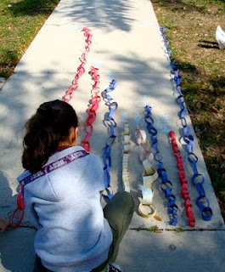
"Did smaller chains or larger chains work the best?"
"Did it matter which way you cut the paper?"

Informal Units
Materials: only 1 unifix or 1 domino

How many dominoes/unifix cubes wide is your table?
-record responses and the initials next to each response
-why did we get different answers? (explore student responses and misconceptions,
start and end point, measuring the space in between, no overlaps or gaps, etc.)

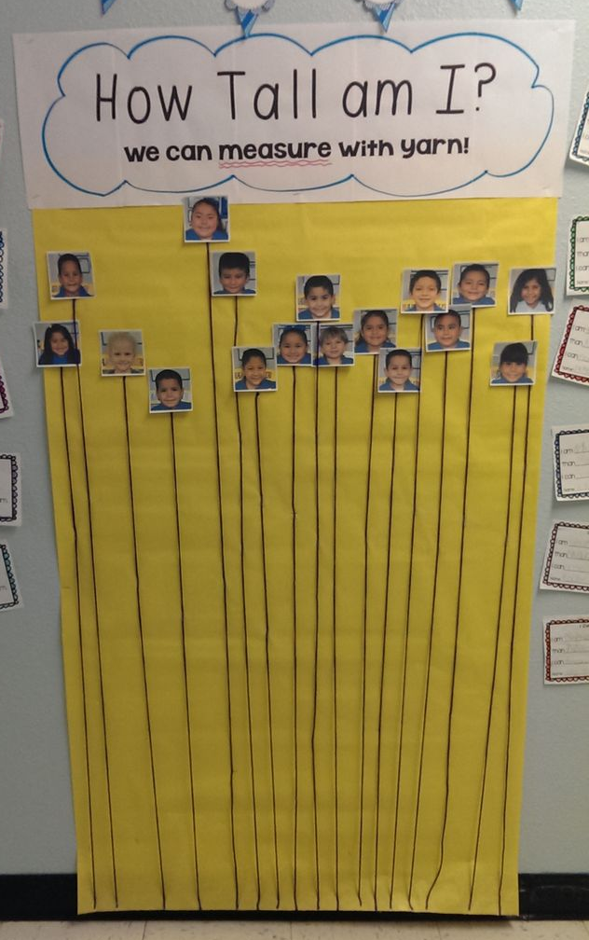

Shorter Than/Longer Than/ The Same As
Find items in the class that are longer, shorter, about the same as …
(the height of your drink bottle/the pipe-cleaner/the popstick/etc.)
How do you know? How could you check?

How Tall Am I?
How tall are you? How could you find out?
-make comparisons between units “I am … unifix cubes tall, I am … dominos tall”
- make comparisons between students “I am … unifix cubes taller than …”

Primary Years- Length

Party Hats
My sister rang me last night and was telling me about the birthday party that her boy Josh went to on the weekend. She thought they had a great activity at the party where the boys and girls made crowns and hats and she wants to do the same for Josh's party in a few weeks’ time. My sister knows where she can buy the cardboard off a big long roll, but she doesn’t know how much to buy. She said she would make the hats a little smaller than the crowns so that the hats could fit on top of their heads. She thought that each of the crowns would need a length of cardboard that was 32cm and the hats would need a length of cardboard that was 26cm. She wanted enough cardboard for 8 crowns and 8 hats. I told her that we were learning about measurement and we could help. Do you think we could help?

Sting in the tail: Each of the hats needs elastic so that they won’t fall off. If each hat needs 15cm of elastic, how much elastic will she need to buy?

Party Balloons
My sister rang me again last night asking for more help with planning Josh's birthday party. She said that josh wanted a mine craft theme for his birthday. He asked for helium balloons that were brown, green and black. My sister wanted to make the balloons at different heights but she didn't know how much ribbon to order. She said she wanted the green balloons to be 1 metre tall, the brown balloons to be 70cm tall and the black balloons to be 1.3 metres tall*. She said she ordered 5 balloons of each colour. I told her not to worry and that we could help. I said that I would call her after school to tell her how much ribbon to buy. Do you think we could help?

*Make lengths more challenging for older students
Look for rainbow facts, near doubles and doubles to help solve the problem, 70cm and 130cm is 2m, plus 1m for each group of balloons.

Sting in the tail: What about extra ribbon for the knots? What if she wanted to buy green, black and brown ribbon to match the balloons, how much ribbon of each colour would she need?

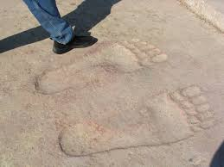
Upper Primary

Animal Tracks (Investigation- incorporating length, perimeter, area, scale, ratio)

http://wonderopolis.org/wonder/do-all-animals-leave-tracks/

How do different animal tracks compare to ours?
What would these comparisons look like in real life?
What are the biggest, smallest animal tracks?
How could you represent these comparisons on an A4 page? (also introduces idea of scale, ratio)

Wonderopolis
http://wonderopolis.org/about/ (a new wonder of the day is posted each day, or you can search and explore past ‘wonders’)

Children, parents, teachers, schools, and families all benefit from Wonderopolis—as well as contribute to its content and growth. Supporting 21st century communication and digital citizenship, visitors who leave comments on the site receive personalized responses from the Wonderopolis team. Users are encouraged to nominate their own Wonders and to vote on Wonder ideas from others.

See more at: http://wonderopolis.org/about/#sthash.NZQuxLcU.dpuf

