Natural Maths Ideas for teaching elapsed time

**[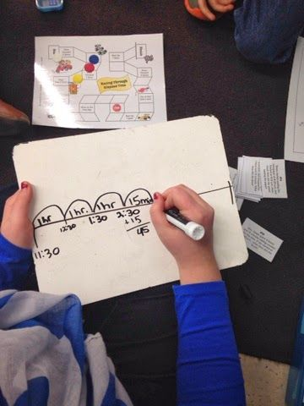](http://flipfloppinthrough.blogspot.com/2014/04/telling-time-we-still-need-practice.html?m=0)**Using an Open Number Line

**[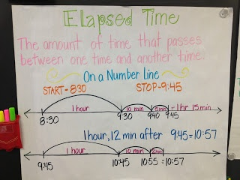](http://mathcoachscorner.blogspot.com/2013/02/strategies-for-elapsed-time.html?utm_source=feedburner&utm_medium=feed&utm_campaign=Feed:+MathCoachsCorner+(Math+Coach's+Corner)&utm_content=Google+Reader)**



**[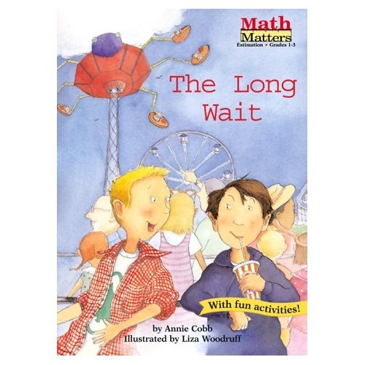](http://www.amazon.com/gp/product/images/1575650940/ref=dp_image_0?ie=UTF8&n=283155&s=books)** Using Chunking/Number splitting Elapsed time text

[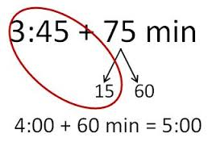](http://www.google.com/url?sa=i&rct=j&q=&esrc=s&frm=1&source=images&cd=&cad=rja&uact=8&docid=QSxn3V_dfzkHFM&tbnid=YVv2N519QcNK0M:&ved=0CAUQjRw&url=http://mathcoachscorner.blogspot.com/2013/08/the-evolution-of-number-bond.html&ei=EJk8U92GNsTVkAWlvYDwDg&bvm=bv.63934634,d.aGc&psig=AFQjCNErIC4ogpQzK3Ng9iZtXZ0LkVPsyA&ust=1396566649806543)

*Karly Hefferan, 2014*