West Torrens Partnership |  | Australian Curriculum Geography and History Integrated Unit Guide  (Draft 18/03/14) |  |  |  |  |  | Year 6
Geography |  |  |  |  |  | History
Key Inquiry Questions |  |  |  | R-7 Concepts |  | Key Inquiry Questions |  |  | R-7 Concepts
- How do places, people and cultures differ across the world?  - What are Australia’s global connections between people and places?  - How do people’s connections to places affect their perception of them? |  |  |  | Place  Space  Environment  Interconnection  Sustainability  Change  Scale |  | - Why and how did Australia become a nation?  - How did Australian society change throughout the twentieth century?  - Who were the people who came to Australia? Why did they come?  - What contribution have significant individuals and groups made to the development of Australian society? |  |  | Sources  Continuity & Change  Cause & Effect  Perspectives  Empathy  Significance  Contestability (Year 7)
Geographical Key Understanding and Knowledge |  |  |  |  |  | Historical Key Understanding and Knowledge
The location of the major countries of the Asia region in relation to Australia and the geographical diversity within the region | Differences in the economic, demographic and social characteristics between countries across the world |  |  |  | The world’s cultural diversity, including that of its indigenous peoples | Key figures and events that led to Australia’s Federation, including British and American influences on Australia’s system of law and government | Experiences of Australian democracy and citizenship, including the status and rights of Aboriginal people and/or Torres Strait Islanders, migrants, women and children
Significant events that connect people and places throughout the world | The various connections Australia has with other countries and how these connections change people and places |  |  |  | The effects that people’s connections with, and proximity to, places throughout the world have on shaping their awareness and opinion of those places | Stories of groups of people who migrated to Australia (including from ONE Asian country) and the reasons they migrated, such as World War II and Australian migration programs since the war | The contribution of individuals and groups, including Aboriginal people and/or Torres Strait Islanders and migrants, to the development of Australian society, for example in areas such as the economy, education, science, the arts, sport
Geographical Inquiry Process |  |  |  |  |  | Historical Inquiry Process
- Observing, questioning and planning  - Collecting, recording, evaluating and representing  - Interpreting, analysing and concluding  - Communicating  - Reflecting and responding |  |  |  |  |  | - Chronology, terms and concepts  - Historical questions and research  - Analysis and use of sources  - Perspectives and interpretations  - Explanation and communication
Cross Curriculum Priorities |  |  | General Capabilities |  |  | Cross Curriculum Priorities | General Capabilities
Literacy Numeracy  ICT capability  Critical and creative thinking  Personal and social capability  Ethical behaviour  Intercultural understanding |  |  | 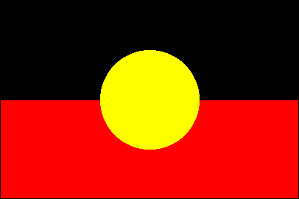  Aboriginal and Torres Strait Islander histories and cultures  Asia and Australia’s engagement with Asia  Sustainability |  |  | Literacy Numeracy  ICT capability  Critical and creative thinking  Personal and social capability  Ethical behaviour  Intercultural understanding | Aboriginal and Torres Strait Islander histories and cultures  Asia and Australia’s engagement with Asia  Sustainability

