8 Great Avatar Creation Tools for Teachers
http://www.educatorstechnology.com/2013/02/8-great-avatar-creation-tools-for.html
Avator tools are like the comic tools I have covered in an earlier post before, they both involve the use of images but in a funny and joyful way. Of course these tools can be used for a variety of educational purposes with our students in the classroom. Let us first see what is an avatar ?
An avatar is a figure or character that you can create and customize the way you want. You can use this character to interact with other friends online . Users have the full control of what they want to feature for example the kind of background, accessories, clothes...etc
Why avatars in education ?
- Avatars are easy and simple to use
- Students can use avatar images in their profiles instead of their real pictures
- Avatar-creation provides students with hands-on activities in identity building
- Using avatars can increase students engagement and keep them focused and on-task
- Students can use avatars in their projects and assignments
Here is how one teacher thinks of using avatars with students :
A group of students in a history class could create an Avatar for different people in history (i.e., President of the United States, Governor of Alabama, African American students and families, White police officers, and Classroom teachers). The students could use the Avatars to demonstrate their understanding of multiple perspectives during the Civil Rights Movement in the years following Brown v. Board of Education.
Here are some of the best web tools to create avatars :
1- Voki
This is a web tool that allows you to easily create speaking characters and customise them the way you want before sharing them with others
2- Build your wild self
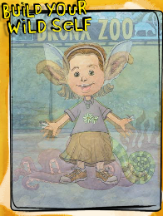
This web tool allows you to first design a human figure then add animal parts to it before you go wild. It is so much fun for kids
3- DoppelMe
DoppleMe is a cool tool that students can use to create avatars to use in the virtual world
4- Frenzoo
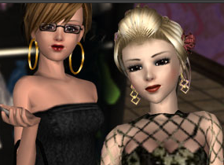
This is another cool tool to use to create avatars. It provides different styles and backgrounds
5- Gavatar
As its name indicates this platform lets you create avatars to use in blogs, and forums. It requires a sign up
6- Clay Yourself
This is an awesome tool for students to use to create clay versions of themselves.
7- Toy Creator
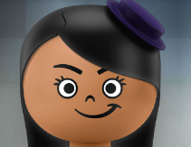
Toy Creator is a tool to create toys and use them in other websites as avatars
8- Wimpy Yourself
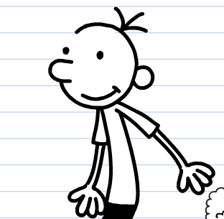
This tool is similar to Clay yourself except it allows you create wimpy versions of yourself and not clay ones

